Tunde Onafowokan – Assignment 1

Qestion1: What is a shell?

Answer: A shell is the Linux layer that receives and interprets commands from the user.

Question2: what is the difference between a shell and kernel?

Answer: The shell is the layer that receives and interprets commands from the user while the kernel is the layer that interacts with the hardware and executes commands interpreted by the shell.

Question3: Create a file called yourname.txt (change yourname to your case)

Question4: cp that file in Q3 to /tmp directory

Question5: create a directory tree p1/p2/p3/p4

Question6: copy that file you create in Q3 into p4 directory

Question7: write down 10 linux commands and their functions

1. pwd = print working directory
2. cd = change directory
3. mkdir = make directory
4. echo = to write in a fille
5. ls = list
6. ll = long list
7. cat = to read a file
8. touch = to create a file
9. cp = copy a file
10. mv = to rename a file.

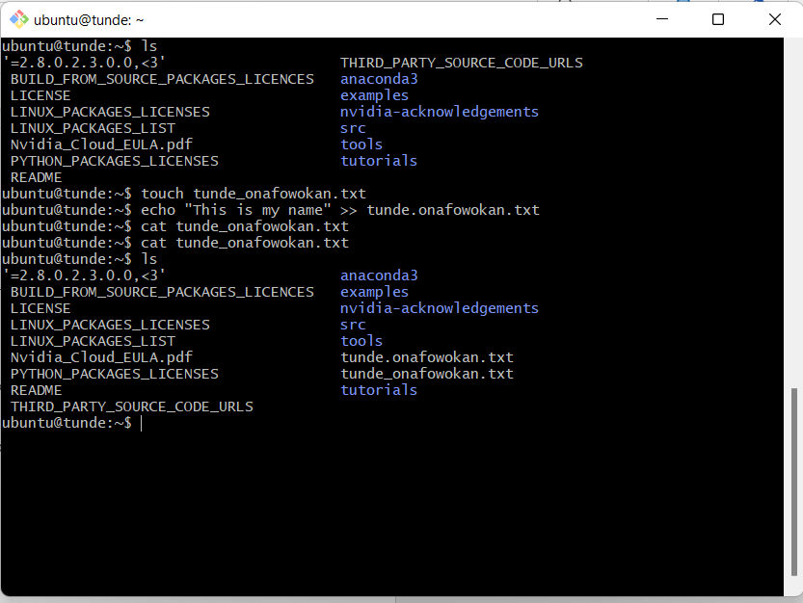

enkengafac@etechconsultllc.com